What I Can Control

What I Can’t Control

My Circle of Control

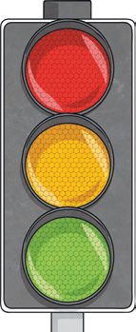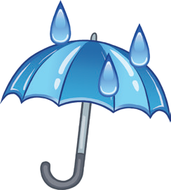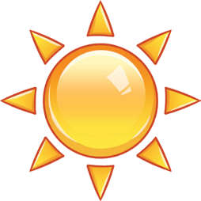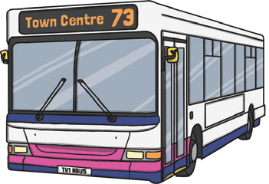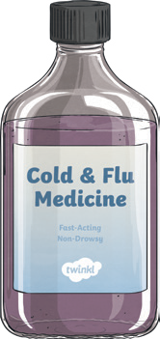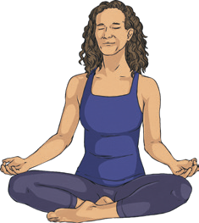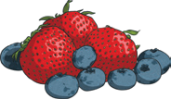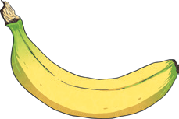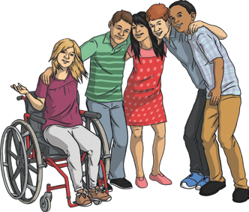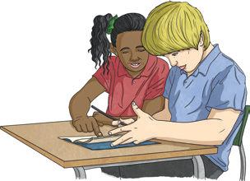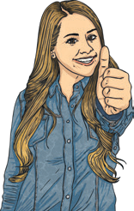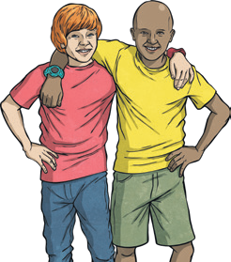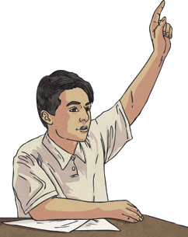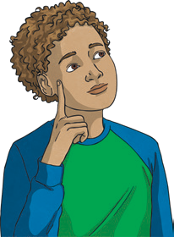

The weather

Being ill

Being kind

Eating healthily

Traffic

Routines in society (bus, train, shop timetables, etc.)

What other people think, feel or say

Apologising if I need to

Using different strategies to help me

Working hard and doing my homework

Past mistakes or bad decisions

Taking care of myself

Asking for help when I need it

How other people behave

My likes and dislikes

Keeping my hands to myself

The friends I choose

Other people being honest

My behaviour and actions

Making the right choices

Predicting what will happen

How other people treat me